**Glucose and homeostasis**

The cells in your body needs glucose (sugar) for energy. The glucose is transported around your body via your blood. The endocrine system works to make sure the amount of sugar in your blood (called the ‘blood sugar content’) is stable at around 90 mg of sugar per 100 mL of blood. The control of blood sugar is a good example of a negative feedback mechanism.

**Insulin:** When blood sugar rises, receptors in the body sense a change. In turn, the effector (pancreas) secretes insulin into the blood. This lowers the amount of sugar in the blood. Once blood sugar levels go back to the normal amount, the pancreas stops releasing insulin.

**Glucagon:** When blood sugar falls too low, receptors in the body sense a change. In turn, the effector (pancreas) secretes glucagon into the blood. Glucagon is broken down in the liver and turned into glucose. Once blood sugar levels go back to the normal amount, the pancreas stops releasing glucagon.

Examine the graphic below to understand how this feedback loop works.

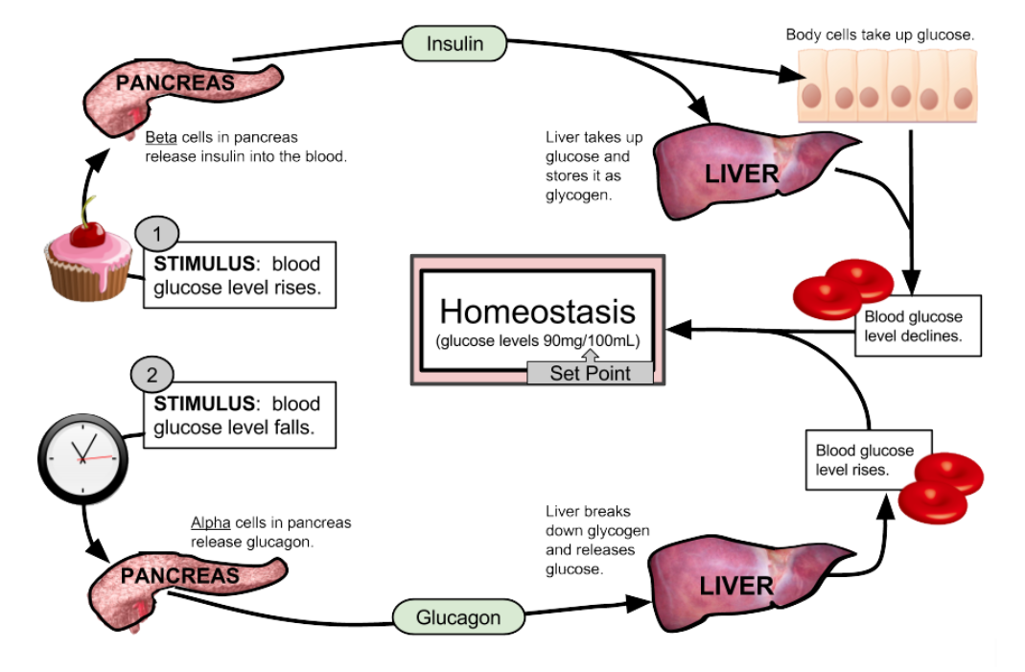

1. What stimulus would cause the pancreas to release insulin?
2. What stimulus would cause the pancreas to release glucagon?
3. What is the effect of insulin? Describe what your liver does, what your cells do and what the result is.
4. What is the effect of glucagon? Describe what your liver does, what your cells do and what the result is.
5. What is the normal level of glucose in the blood? Why is this called a “set point”?
6. Why is blood sugar control an example of a negative feedback?
7. What would you expect to happen if your blood sugar was 120 mg / 100 mL? Be specific.
8. Why do we say that the pancreas is part of the endocrine system and not the nervous system? Think about the speed of the response and how it transmits information around the body.
9. A person with diabetes cannot regulate their blood sugar because the pancreas does not release enough insulin. To treat the disease, a person must monitor their blood sugar. If their blood sugar is high, they must take an injection of insulin. How do you think they would need to treat low blood sugar?